**DAILY ONLINE ACTIVITIES SUMMARY**

|  |  |  |  |  |  |  |  |  |
| --- | --- | --- | --- | --- | --- | --- | --- | --- |
| **Date:** | **24/05/2020** | | | | | **Name:** | **NAIPUNYA VINOD NAIK** | |
| **Sem & Sec** | **IV SEM & A SECTION** | | | | | **USN:** | **4AL18CS050** | |
| **Online Test Summary** | | | | | | | | |
| **Subject** | | **NO TEST CONDUCTED** | | | | | | |
| **Max. Marks** | | **NIL** | | **Score** | | | **NIL** | |
| **Certification Course Summary** | | | | | | | | |
| **Course** | **JAVA PROGRAMMING** | | | | | | | |
| **Certificate Provider** | | | **GREAT LEARNING ACADEMY** | | **Duration** | | | **3.5 HRS** |
| **Coding Challenges** | | | | | | | | |
| **Problem Statement: NOT GIVEN** | | | | | | | | |
| **Status: ------------------------** | | | | | | | | |
| **Uploaded the report in Github** | | | | | **YES** | | | |
| **If yes Repository name** | | | | | **---------------------** | | | |
| **Uploaded the report in slack** | | | | | **YES** | | | |

Online Test Details: (Attach the snapshot and briefly write the report for the same)

NO TEST WAS CONDUCTED.

Certification Course Details: (Attach the snapshot and briefly write the report for the same)

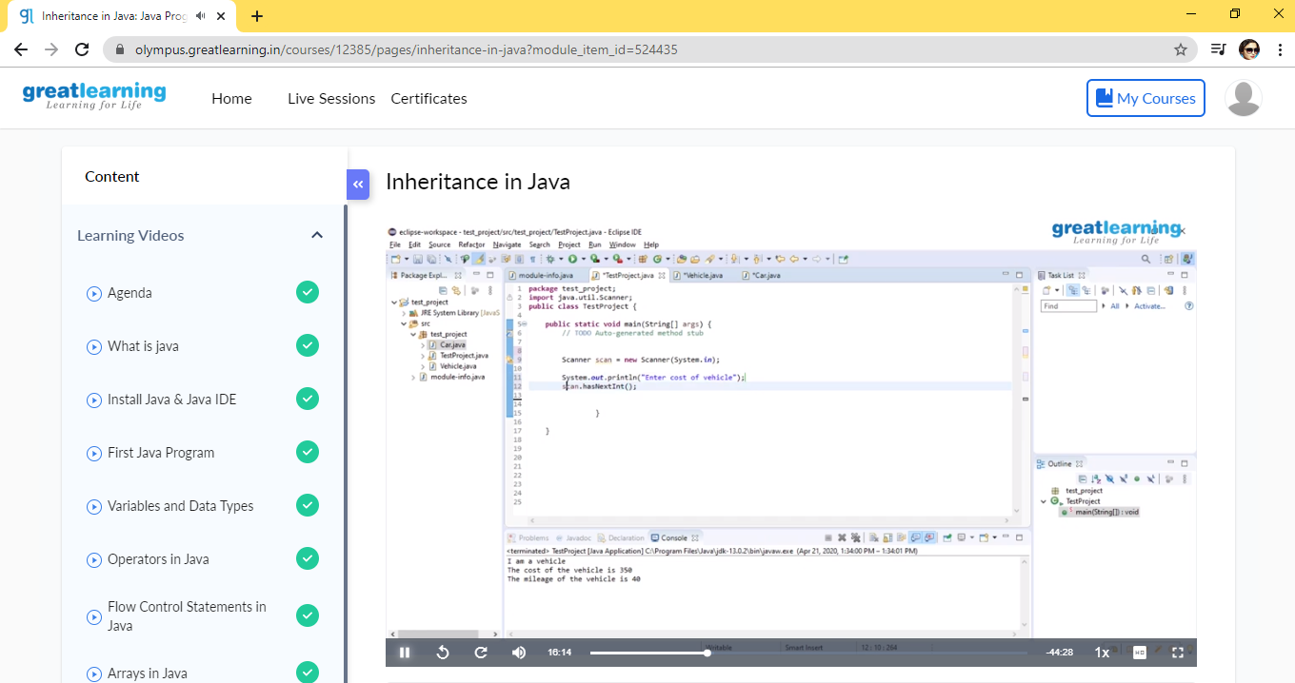

TOPICS LEARNT ON 24 MAY 2020:-

* INHERITANCE IN JAVA
* MULTILEVEL INHERITANCE IN JAVA
* ABSTRACT LEVEL IN JAVA
* INTERFACE IN JAVA
* EXTEND AND IMPLEMENT

Coding Challenges Details: (Attach the snapshot and briefly write the report for the same)

PROBLEM STATEMENTS WERE NOT GIVEN ON THIS DAY.